17th Annual
BOULEVARD OF WHEELS CUSTOM CAR SHOW
Presented by Street DREAMS CORVETTE CLUB, INC.

*TOP HONOR AWARDS*
Top 50 Awards
Sponsors Choice & Specialty Awards
Best Corvette in Show Award
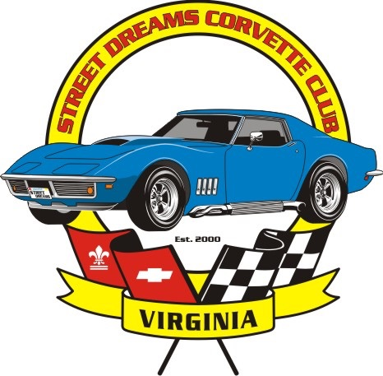
Best in Show Award

Dash Plaques ∙ Trophies ∙ Goodie Bags ∙ 50/50 Raffle ∙ Prizes ∙ Music ∙ Food

Show schedule
9:00am–12:00pm registration 12:00pm Judging will start
2:30pm award ceremony 3:00pm end of show

Make checks payable to Street Dreams Corvette Club. Mail to P.O. Box 6758 Virginia Beach, VA 23456. All pre-registrations must be received by August 28, 2025. For more info call (757)717-4523 or email jpdav@cox.net

Liability release: Entrance and participants release and discharge Street Dreams Corvette Club and their sponsors from any damages, injuries and or losses that may be suffered by any entrant or participants to person or property. Please bring proof of insurance.

Name_________________________________________________________________

Address_______________________________________________________________

City _________________________________________ State____________

Zip________________________

Phone ______________________________________

E-mail________________________________________________________________

Year ___________ Make _________________ Model ______________________

Color_________________________________________________________________

Club Affiliation_________________________________________________________

Signature__________________________________________ Date_______________

Amount Enclosed_____________

Rules, regulation and policies: SDCC club members, sponsors or affiliates are not eligible for trophies raffles or prize money. Any lewd behavior, irresponsible driving and/or conduct deemed objectionable to the events’ well-being may result in participant being disqualified and or escorted off the premises and denied any further involvement in this event and/or future events hosted by Street Dreams Corvette Club, Inc.

